[1] CSA-1557 CLOUD COMPUTING LAB PRACTICALS

2.Create a Virtual Machine with 1 CPU, 2GB RAM and 15GB storage disk using a Type 2 Virtualization Software.

Step-1:

First install VMware workstation on your pc/laptop. Then open the VM software and click create a new virtual machine displayed on a home tab.

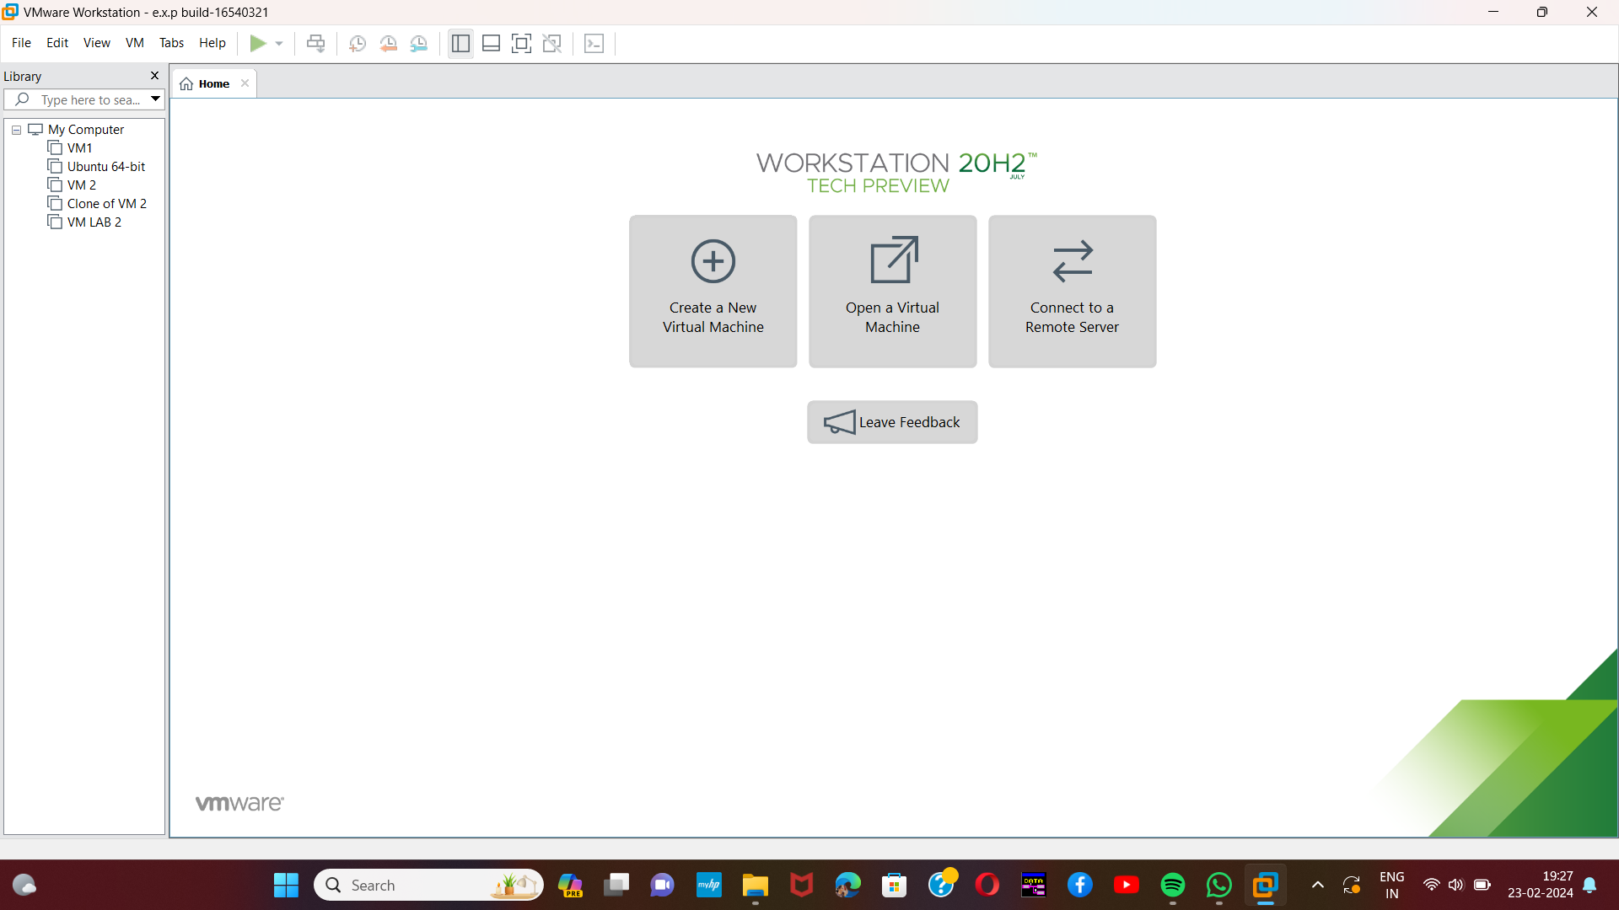

Step-2:

Then the below shown message will be displayed and click next.

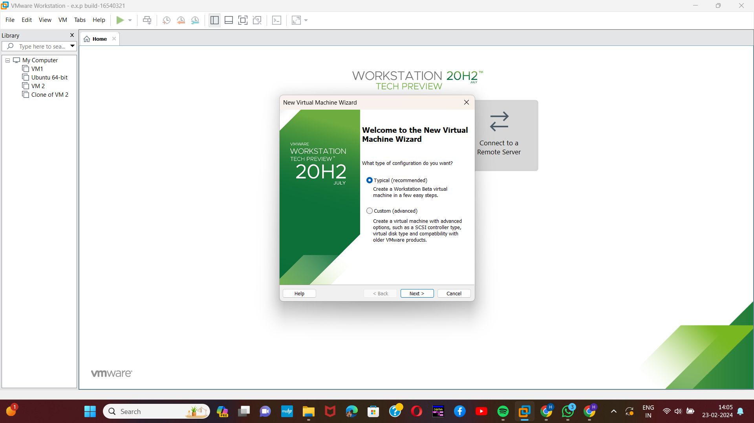[2]

Step-3:

Here,we are going to Create a Virtual Machine with 1 CPU, 2GB RAM and 15GB storage disk using a Type 2 Virtualization Software. So need of any installer.just click the third option and next.

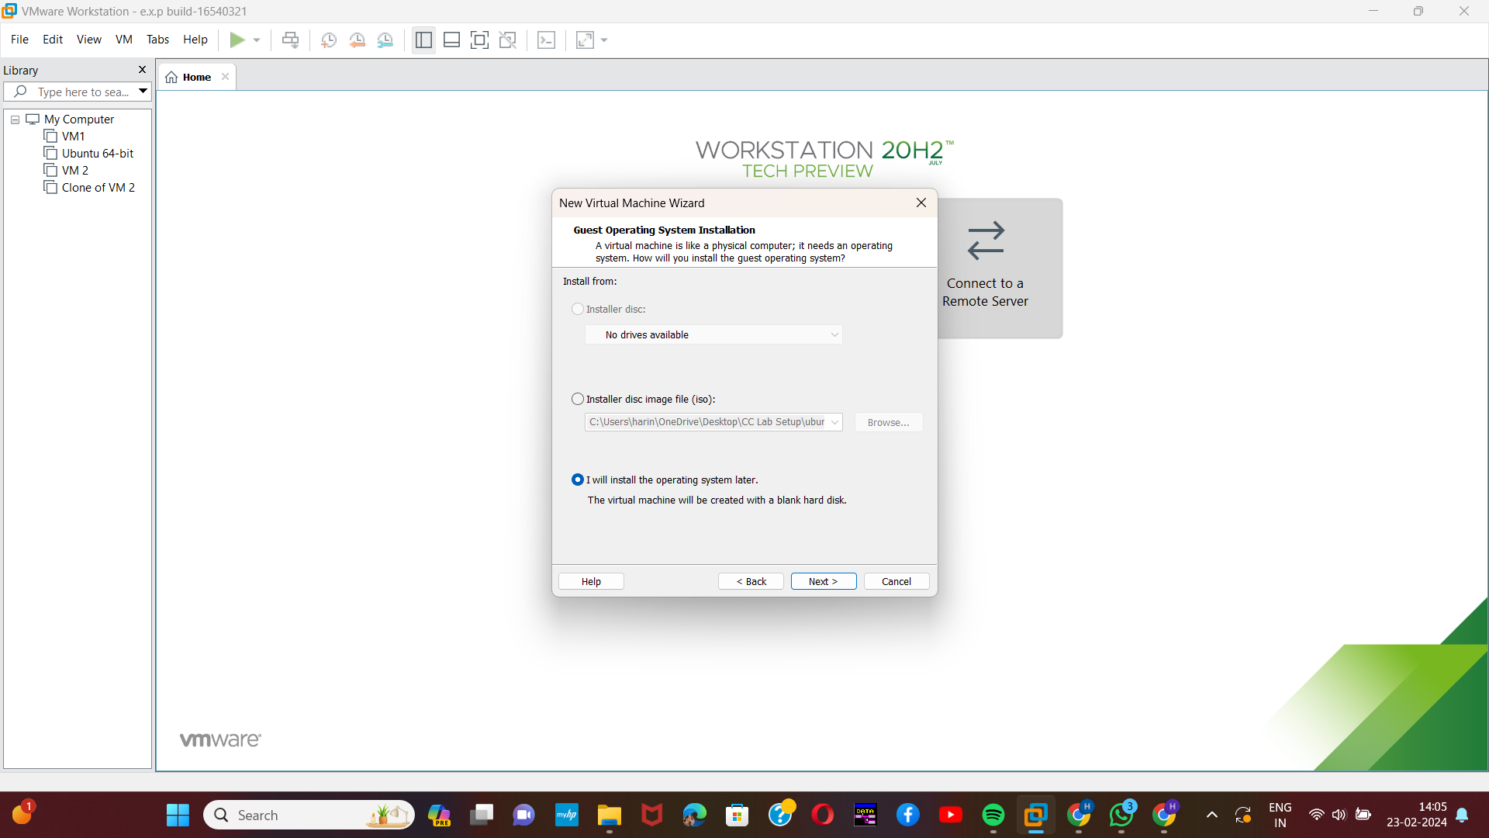[3]

Step-4:

Then provide an appropriate name for our virtual machine.

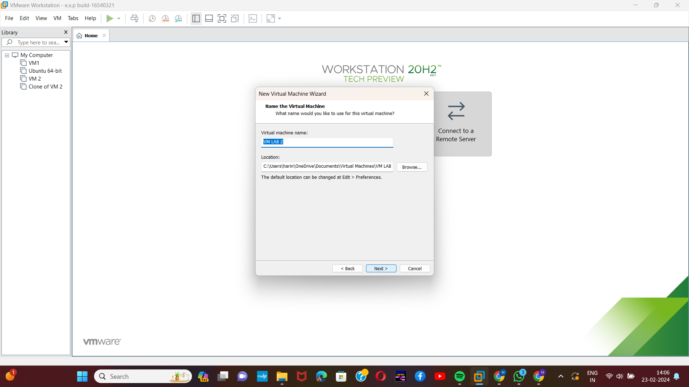

[4]Step-5:

Then provide appropriate hard disk size.

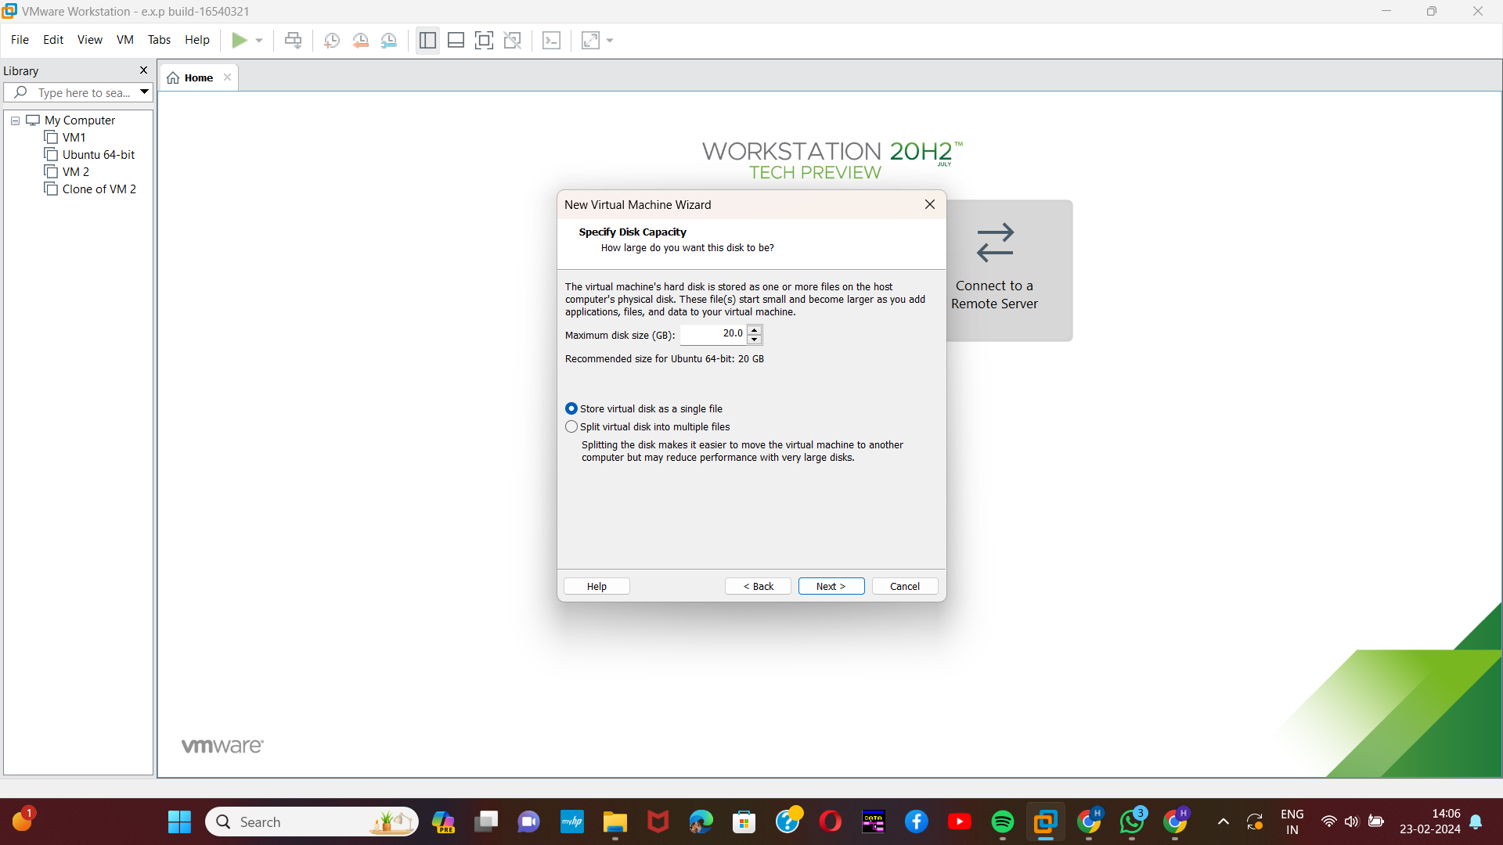

Step-6:

Then verify all the given details are correct and if any changes ,correct it with the customise hardware option.

[5] 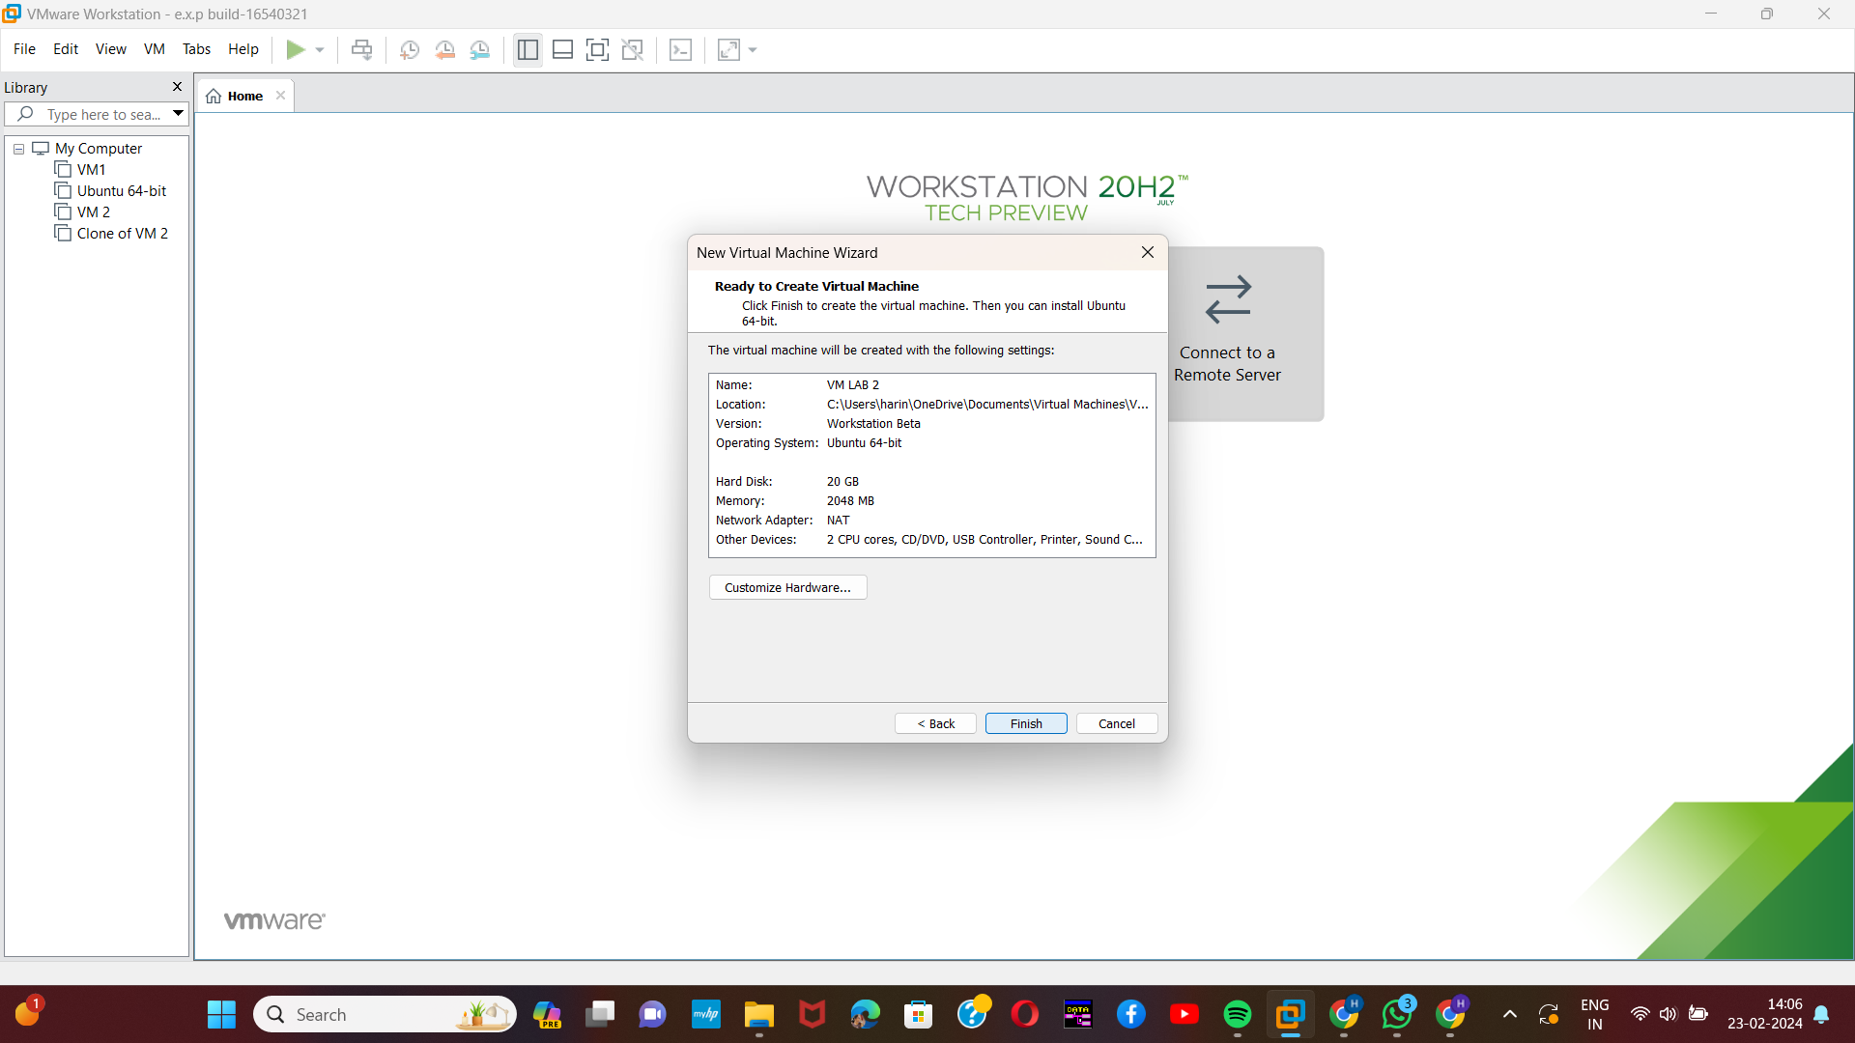

Step-7:

Our VM was created and all the specifications were listed on the left side.

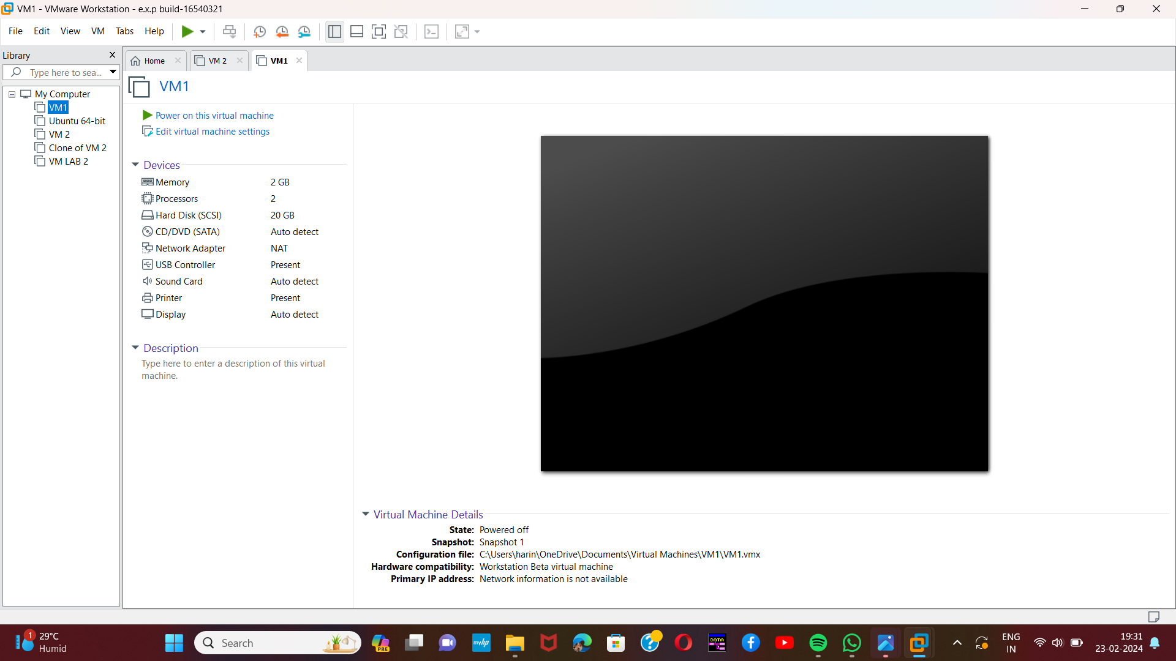

1. Harini 192221109
2. Harini 192221109
3. Harini 192221109
4. Harini 192221109
5. Harini 192221109